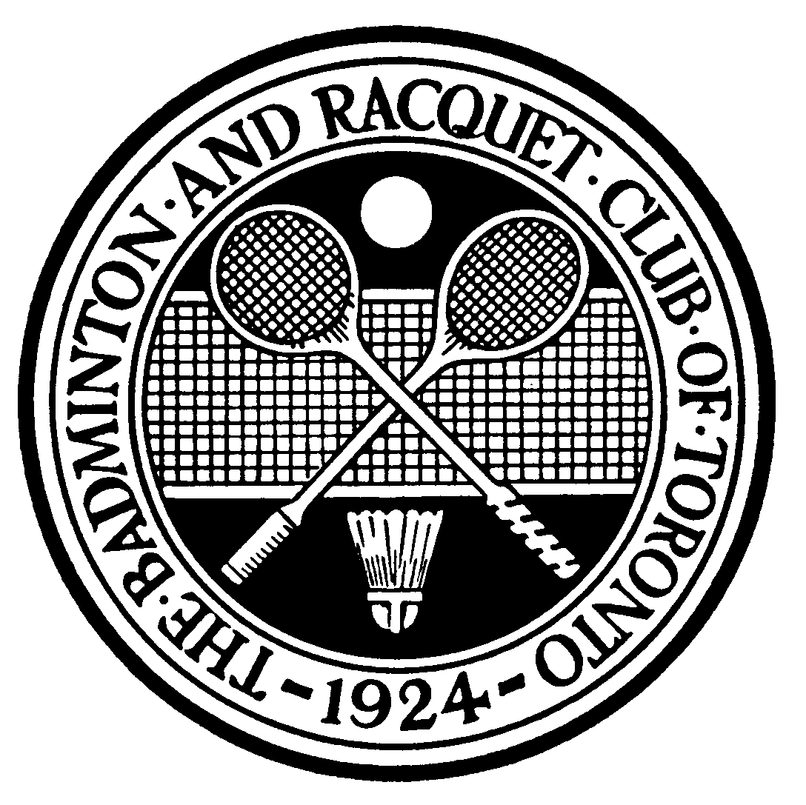  Men’s  Class 1  2006  Canadian  Racketlon |  | Albert Wong
 |  | Fri 4:45 PM #18 |  | Albert Wong
 |  |  |  | 21-5,21-4,7-21,21-5 (+28)
 |  | Jacob Shoihet
 |  |  |  | Sat 10:30 AM #51 |  | Albert Wong
 |  |  |  |  |  | 21-14,21-4,13-21,20-21 (+15)
 |  | Steve Du
 |  | Fri 4:00 PM #11 |  | Powles
 |  |  |  | 21-20,19-21,21-7,13-21 (+5)
 |  | Colin Powles
 |  |  |  |  |  | Sat 1:30 PM #75 |  | Albert Wong
 |  |  |  |  |  |  |  | 21-3,21-12,2-21,21-10 (+19)
 |  | Dave Shaw
 |  | Fri 5:30 PM #23 |  | Dave Shaw
 |  |  |  | 21-6,1-21,13-21,21-3 (+5)
 |  | Peter Butler
 |  |  |  |  |  |  |  | Alain Vnadergheynst beat
 |  |  |  | Sat 10:30 AM #52 |  | Daryl Des Barres |  | Daryl Des Barres
Daryl Des Barres |  |  |  |  |  | 21-20,21-14,21-7,5-21 (+11) |  | 21-14, 21-18, 2-21, 21-5 (+7)
Fri 3:00 PM #5 |  | Daryl Des Barres
Maxx Sholz |  | 21-9,21-13,21-10,21-19 (+33) |  |  |  |  |  | ¾ PLAYOFF
 |  | Fri 6:15 PM #30 |  | Daryl Des Barres |  |  |  | Sun 11:00 AM #94
 |  |  |  | 20-21,21-10,21-11,5-21 (+4)
 |  | Peter Giacomelli
 |  |  |  |  |  |  |  |  |  | Ken Berger
 |  |  |  |  |  |  |  | FINALS |  | 21-10, 2-21, 21-3, 21-12  (+19)
 |  | Michael von Graffen |  |  |  |  |  | Sun 11:40 AM #99
 |  | Fri 6:30 PM #31 |  | Alain Vandergheynst
 |  |  |  | 21-14,21-5,8-21,21-19 (+12)
 |  | Alain Vandergheynst
 |  |  |  | Sat 10:45 AM #53 |  | Alain Vandergheynst
 |  |  |  |  |  | 15-21,10-21,21-11,21-6 (+8)
 |  | Cameron Dunning
 |  | Fri 5:30 PM #24 |  | Cameron Dunning
 |  |  |  | 2-21,21-0,21-0 (+40)
 |  | Chandru Krishnan
 |  |  |  |  |  | Sat 1:30 PM #76 |  | Ken Berger
 |  |  |  |  |  |  |  | 21-11,2-21,21-7,21-11 (+15)
 |  | Gordo Urquhart
 |  | Fri 5:45 PM # 25 |  | Gordo Urguhart
 |  |  |  | 21-12,21-11,21-5 (+25)
 |  | Marc Di Nardo
 |  |  |  | Sat 10:45 AM #54 |  | Ken Berger
 |  |  |  |  |  | 21-6,10-21,19-21,21-10 (+14)
 |  | Ross Golding
 |  | 7:30 PM #38 |  | Ken Berger
 |  |  |  | 21-7,8-21,21-5,21-0 (+39)
 |  | Ken Berger

